DCC-GARCH correlation: GBPUSD and USDCAD
Method 09 / GARCH(1,1) + Engle DCC / Alpari D1 full available history

Study setup
Logical pair: GBPUSD , USDCAD
Broker symbols: GBPUSD_i , USDCAD_i
Snapshot: 2026-11-03_majors_alpari_D1
Timeframe: D1
Matched return window: 1999-01-05 to 2026-11-02 (UTC bar dates)
Matched return count n: 7205
Dropped unfinished last bar dated 2026-11-03 UTC after a tick-volume check against the prior complete day.
GBPUSD GARCH(1,1): mu=0.000021, omega=0.003975, alpha=0.054995, beta=0.932736
USDCAD GARCH(1,1): mu=-0.000005, omega=0.001251, alpha=0.043587, beta=0.951299
DCC: a=0.014757, b=0.982838, a+b=0.997594
Burn-in ignored in path summaries and chart: first 60 updates
Complete matched rows (Excel): GBPUSD-USDCAD_DCC_D1.xlsx
Complete matched rows (HTML table): GBPUSD-USDCAD_DCC_D1_data.html

Method carried forward
DCC-GARCH first fits a constant-mean GARCH(1,1) on each matched daily log return of close, ln(close_t / close_t-1), then updates Engle (2002) dynamic conditional correlation on the standardised shocks z = residual / conditional sigma. Quotes are not inverted. Correlation targeting sets Q_bar to the sample correlation of z; a and b are estimated by maximising the bivariate Gaussian DCC likelihood with a >= 0, b >= 0, and a + b < 1. Path summaries ignore the first 60 updates. The headline is rho on the last day. Same-sample Pearson r on log returns is a side check only. A high |rho| does not prove cause, lead-lag, or a trading signal.

Results
Latest DCC rho: -0.588185
Post-burn-in path (n=7145): mean=-0.409156, median=-0.440398, min=-0.706443, max=0.124686, std=0.167576
Share of post-burn-in days with |rho| >= 0.4: 59.43%; |rho| >= 0.7: 0.03%
Same-sample Pearson r: -0.456462
Latest rho minus r: -0.131722

Conclusion
Over 7205 matched daily log-return rows for GBPUSD and USDCAD (broker quote directions unchanged), latest DCC rho is -0.5882 (negative, moderate conditional linear link in this sample) with fitted a=0.0148, b=0.9828 (a+b=0.9976). After a 60-day burn-in, path mean is -0.4092 and std is 0.1676. Same-sample Pearson r is -0.4565 (latest rho minus r = -0.1317). This does not establish cause, lead-lag, or a lasting trading rule.

Charts
Daily closes

Daily log returns
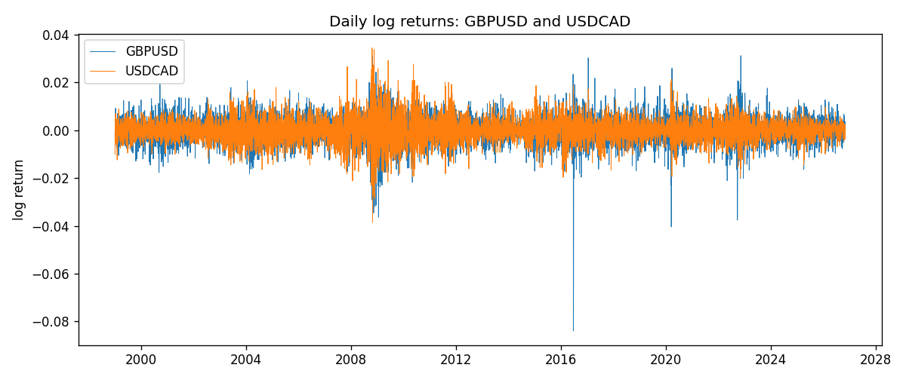
DCC rho path with Pearson r reference
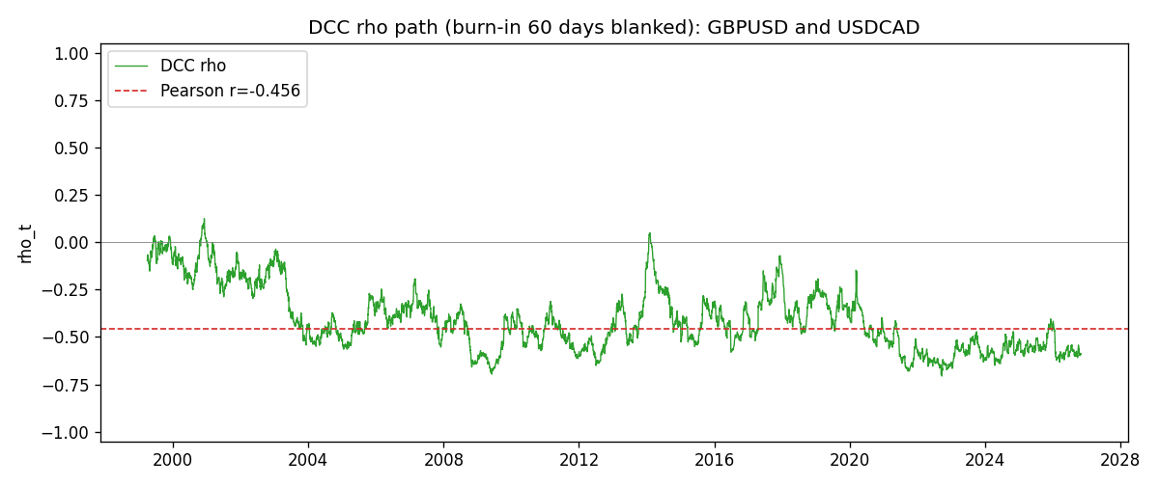

Data report
Every matched row that entered the DCC recursion is stored in the sibling Excel workbook named GBPUSD-USDCAD_DCC_D1.xlsx. Embedding all rows as a Word table is impractical at this length; the Word file holds the column list, column summaries, and the first and last 15 matched rows.
Columns: time, GBPUSD_open, USDCAD_open, GBPUSD_high, USDCAD_high, GBPUSD_low, USDCAD_low, GBPUSD_close, USDCAD_close, GBPUSD_tick_volume, USDCAD_tick_volume, GBPUSD_spread, USDCAD_spread, GBPUSD_real_volume, USDCAD_real_volume, GBPUSD_log_return, USDCAD_log_return, GBPUSD_sigma, USDCAD_sigma, GBPUSD_z, USDCAD_z, q11, q22, q12, rho_t
Column summaries (matched calculation rows)
column | count | mean | std | min | 25% | 50% | 75% | max
GBPUSD_open | 7205 | 1.5161639 | 0.2182756 | 1.06854 | 1.32505 | 1.51142 | 1.63205 | 2.1066
USDCAD_open | 7205 | 1.2670469 | 0.16900802 | 0.9168 | 1.119 | 1.29857 | 1.3723 | 1.6183
GBPUSD_high | 7205 | 1.5224596 | 0.21884187 | 1.08366 | 1.32981 | 1.5182 | 1.6384 | 2.1161
USDCAD_high | 7205 | 1.2719479 | 0.16896591 | 0.9336 | 1.1234 | 1.30394 | 1.3769 | 1.619
GBPUSD_low | 7205 | 1.5098441 | 0.21750249 | 1.03518 | 1.31956 | 1.50336 | 1.62444 | 2.0983
USDCAD_low | 7205 | 1.2624879 | 0.16904619 | 0.9056 | 1.1144 | 1.29361 | 1.36793 | 1.6102
GBPUSD_close | 7205 | 1.5162333 | 0.21823062 | 1.06879 | 1.3252 | 1.5114 | 1.6322 | 2.1065
USDCAD_close | 7205 | 1.2670655 | 0.16898286 | 0.916 | 1.11851 | 1.29871 | 1.37253 | 1.6137
GBPUSD_tick_volume | 7205 | 94776.836 | 153518.92 | 62 | 9986 | 52867 | 91739 | 1273370
USDCAD_tick_volume | 7205 | 80835.261 | 147176.39 | 37 | 5509 | 40849 | 71515 | 1410818
GBPUSD_spread | 7205 | 26.978348 | 19.192834 | 0 | 11 | 20 | 50 | 50
USDCAD_spread | 7205 | 23.508952 | 18.282466 | 0 | 9 | 17 | 40 | 60
GBPUSD_real_volume | 7205 | 3.5541156e+09 | 8.441481e+10 | 0 | 0 | 0 | 0 | 2.4038164e+12
USDCAD_real_volume | 7205 | 1.8330194e+10 | 9.6578305e+10 | 0 | 0 | 0 | 0 | 2.5751613e+12
GBPUSD_log_return | 7205 | -2.188e-05 | 0.00563988 | -0.08388241 | -0.00312535 | 3.221e-05 | 0.0031749 | 0.03112653
USDCAD_log_return | 7205 | -1.219e-05 | 0.00514402 | -0.03859748 | -0.00283601 | 4.92e-05 | 0.00272763 | 0.03436319
GBPUSD_sigma | 7205 | 0.00539059 | 0.00169172 | 0.00300172 | 0.00447484 | 0.00503171 | 0.00576407 | 0.02192746
USDCAD_sigma | 7205 | 0.00479571 | 0.00181262 | 0.00250953 | 0.00365721 | 0.00435895 | 0.00535476 | 0.01852289
GBPUSD_z | 7205 | -0.00681184 | 1.0000225 | -10.32614 | -0.60097345 | 0.00239338 | 0.60673152 | 4.9475886
USDCAD_z | 7205 | 0.00156339 | 1.0000914 | -4.0699941 | -0.62903578 | 0.01123275 | 0.61274549 | 6.418043
q11 | 7205 | 1.0017997 | 0.16102533 | 0.60584504 | 0.91815417 | 0.98586646 | 1.0561976 | 2.8242036
q22 | 7205 | 1.0015982 | 0.1349083 | 0.70235551 | 0.91323362 | 0.98581758 | 1.0666684 | 1.7603852
q12 | 7205 | -0.4115358 | 0.18686722 | -1.0811473 | -0.53174405 | -0.43857841 | -0.2989248 | 0.13148115
rho_t | 7205 | -0.40744865 | 0.16804734 | -0.70644253 | -0.53953364 | -0.43774169 | -0.31077911 | 0.12468568
First 15 matched rows (selected columns)
time | GBPUSD_log_return | USDCAD_log_return | GBPUSD_sigma | USDCAD_sigma | GBPUSD_z | USDCAD_z | q11 | q22 | q12 | rho_t
1999-01-05 | -0.0028966287 | -0.010131666 | 0.0040778685 | 0.0045249981 | -0.71548762 | -2.2378296 | 1 | 1 | -0.41194472 | -0.41194472
1999-01-06 | -0.00060452184 | -0.0003306769 | 0.0040467385 | 0.0049064152 | -0.15458315 | -0.066277754 | 0.99279755 | 1.0591434 | -0.38223808 | -0.37275734
1999-01-07 | -0.002118709 | 0.0015202092 | 0.003961508 | 0.0047989873 | -0.54013389 | 0.31792121 | 0.978517 | 1.0434364 | -0.37651774 | -0.3726218
1999-01-08 | -0.0058954193 | -0.0020495197 | 0.003909883 | 0.0047048142 | -1.5132051 | -0.43445478 | 0.96843413 | 1.0294257 | -0.37358081 | -0.3741554
1999-01-11 | -0.0056851331 | -0.0035137769 | 0.004072031 | 0.0046221759 | -1.4013078 | -0.75901184 | 0.98800902 | 1.0169493 | -0.35845886 | -0.35760964
1999-01-12 | 0.0022657001 | 0.0066194721 | 0.0042016923 | 0.0045810087 | 0.53422863 | 1.4461799 | 1.0024354 | 1.010403 | -0.33760237 | -0.33545169
1999-01-13 | 0.0091330396 | 0.0045420214 | 0.0041402021 | 0.0046906053 | 2.2008597 | 0.96949366 | 0.9918484 | 1.0263305 | -0.32139833 | -0.31854981
1999-01-14 | 0.0019376331 | 0.0069376546 | 0.0045773254 | 0.0046858053 | 0.41871555 | 1.48174 | 1.0487102 | 1.024992 | -0.28538651 | -0.27526149
1999-01-15 | -0.0017558204 | -0.0056905671 | 0.0044879916 | 0.0048076796 | -0.39591343 | -1.182499 | 1.0357046 | 1.0422056 | -0.27232405 | -0.26211468
1999-01-18 | 0.0012112405 | 0.00098344542 | 0.0043998088 | 0.0048499462 | 0.27051282 | 0.20390662 | 1.0226481 | 1.0473589 | -0.26173265 | -0.25289894
1999-01-19 | 0.0018745281 | 0.002748513 | 0.0043048297 | 0.004748073 | 0.43056114 | 0.58002555 | 1.0085825 | 1.0324029 | -0.25741769 | -0.25226562
1999-01-20 | -0.0049053846 | -0.0059646885 | 0.0042274623 | 0.0046799565 | -1.1653375 | -1.2733447 | 0.9964141 | 1.0220546 | -0.25030546 | -0.24803521
1999-01-21 | 0.0031518998 | -0.0042823796 | 0.0042896968 | 0.0047442945 | 0.72985673 | -0.9014805 | 1.0017587 | 1.0308461 | -0.22510335 | -0.22151517
1999-01-22 | 0.0024781662 | 0.0025057712 | 0.0042544416 | 0.0047259459 | 0.57754476 | 0.53137762 | 0.99483258 | 1.0275523 | -0.23194026 | -0.22940305
1999-01-25 | 0.0012066366 | 0.00085579808 | 0.0041966967 | 0.0046526187 | 0.28250812 | 0.18511914 | 0.98508672 | 1.0164894 | -0.22442181 | -0.2242727
Last 15 matched rows (selected columns)
time | GBPUSD_log_return | USDCAD_log_return | GBPUSD_sigma | USDCAD_sigma | GBPUSD_z | USDCAD_z | q11 | q22 | q12 | rho_t
2026-10-13 | 0.0036434319 | -0.0046395653 | 0.0036678569 | 0.0028858202 | 0.98760563 | -1.6058085 | 0.77876105 | 0.82510952 | -0.45146425 | -0.56320364
2026-10-14 | -0.0049164679 | 0.0015184751 | 0.0036969375 | 0.0029972535 | -1.3355659 | 0.50845408 | 0.7821945 | 0.85140642 | -0.46810988 | -0.57361694
2026-10-15 | 0.0065976411 | -0.0036101503 | 0.0038060747 | 0.0029618226 | 1.7279234 | -1.217041 | 0.79749798 | 0.84301486 | -0.47108792 | -0.57453906
2026-10-16 | 0.0037592051 | -0.0034322068 | 0.0040358264 | 0.0030061033 | 0.92624632 | -1.1399196 | 0.83027622 | 0.8528099 | -0.49502674 | -0.58828969
2026-10-19 | -0.0017500314 | -0.0018835331 | 0.0040445342 | 0.0030386702 | -0.43789151 | -0.61804746 | 0.83109262 | 0.85975446 | -0.50310277 | -0.59517513
2026-10-20 | 0.0055923442 | -0.0037066008 | 0.0039784282 | 0.0030104334 | 1.4003793 | -1.2294277 | 0.82206429 | 0.85304145 | -0.49146556 | -0.58688787
2026-10-21 | 0.0012476328 | -0.00084691787 | 0.0041070328 | 0.0030567217 | 0.29865772 | -0.2752711 | 0.83930027 | 0.86311159 | -0.50942805 | -0.59853658
2026-10-22 | 0.00022396082 | -0.0026307268 | 0.0040265773 | 0.0030074091 | 0.050396416 | -0.87292286 | 0.82861773 | 0.85182232 | -0.50288921 | -0.59857793
2026-10-23 | -0.0021146949 | 2.85545e-05 | 0.0039398566 | 0.003004924 | -0.54208335 | 0.01132981 | 0.81683975 | 0.8508532 | -0.49589859 | -0.59483584
2026-10-26 | -0.0024340661 | 5.7106554e-05 | 0.0038893024 | 0.0029521199 | -0.6312448 | 0.021204176 | 0.80956278 | 0.83865803 | -0.4884694 | -0.59281562
2026-10-27 | -0.0023648393 | 0.0025379458 | 0.0038520295 | 0.0029010163 | -0.61938132 | 0.87673981 | 0.80395448 | 0.82667689 | -0.4812746 | -0.59034965
2026-10-28 | 0.0015771808 | -0.0038379274 | 0.0038145206 | 0.0029005415 | 0.40795297 | -1.3212832 | 0.7982235 | 0.82623788 | -0.48201922 | -0.5935394
2026-10-29 | 0.0035881935 | -0.00011436495 | 0.0037553253 | 0.0029612053 | 0.94989316 | -0.036766865 | 0.78938559 | 0.8402255 | -0.48269182 | -0.59268975
2026-10-30 | 0.0013450605 | -0.0010298736 | 0.0037750663 | 0.0029098711 | 0.35072886 | -0.35203719 | 0.79155845 | 0.82823077 | -0.47591403 | -0.5877753
2026-11-02 | 0.0010971256 | 0.00061519094 | 0.0037130043 | 0.0028680764 | 0.28981647 | 0.21641043 | 0.78219426 | 0.81825077 | -0.4705592 | -0.58818473

